**Project Document: <DataCompany> and <ClientCompany>**

**Collaboration**

**Presented By:**

**Mr. Sriniwas Jha**

**Co-Founder, Data Pit**

**Project Overview**

**Project Parties:**

- DataCompany

- ClientCompany

**Project Description:**

The collaboration between DataCompany and ClientCompany aims to develop a comprehensive suite of modules utilizing advanced technologies to enhance language translation, optical character recognition, audio-video translation, facial recognition, and document search capabilities. These modules will be built using the Django framework and can be configured for both user-accessible and non-user-accessible environments.

**Module Descriptions**

**Module 1: PDF Translator**

Expected Costs: $250,000

This module will facilitate the translation of PDF documents containing Chinese, Arabic, Pashto, Russian, Turkish, Urdu, Bangla and Persian into English. It will preserve formatting elements such as background color, boldness, italics, and font size. GPU acceleration and training data will be used to achieve an expected translation accuracy ranging from 75% to 95%. The work is expected to finish within 6 to 8 months from the starting date.

**Example Output:**

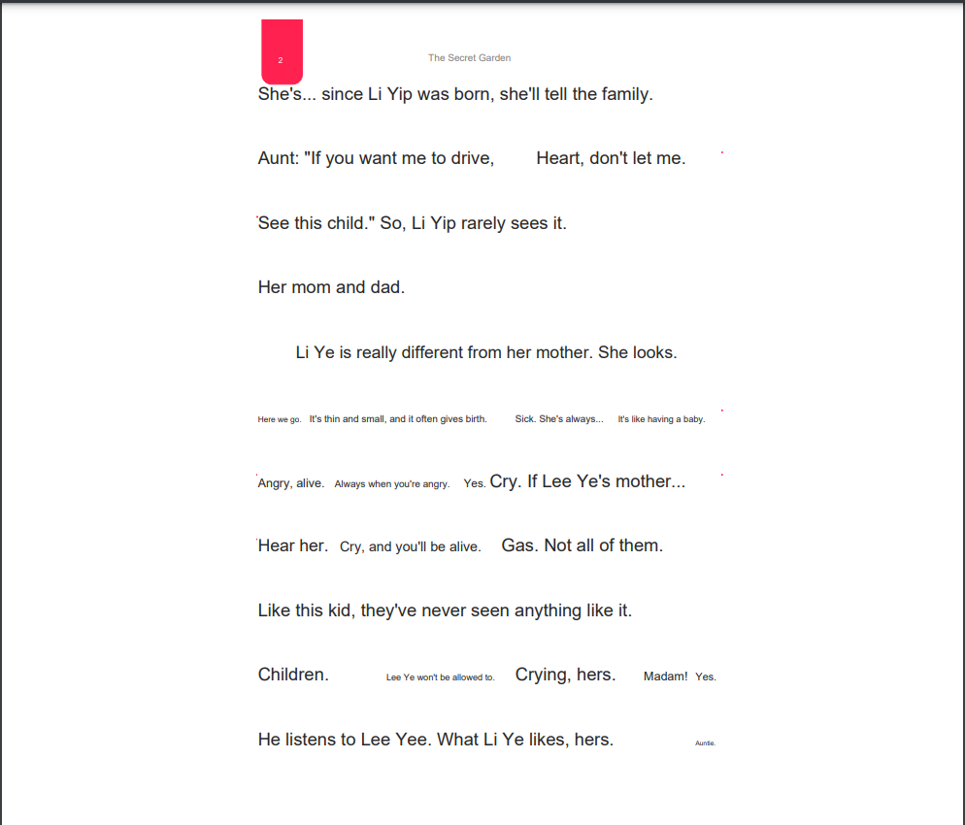

**Fig 1. An example of Translated PDF**

**Module 2: Crumbled Paper OCR**

#### Expected Costs: $100,000

The Crumbled Paper OCR module will perform Optical Character Recognition on images of creased or crumbled paper documents. It will accurately extract text from such challenging images and provide a text file along with annotated images displaying text boxes and corresponding text. Customization and model adjustments are possible. High-level compute power and a GPU are required for implementation, testing, and deployment. The module is expected to complete within 6 to 8 months since the starting date.

**Example Output:**

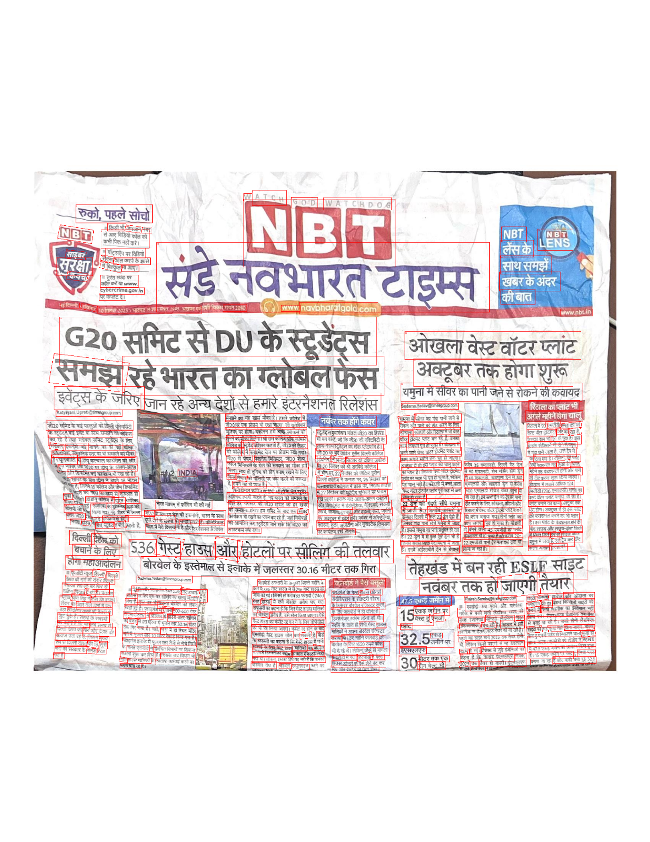

**Fig 2. An example of OCR on a Crumbled Paper**

**Module 3: Audio and Video Translation**

#### Expected Costs: $200,000

This module will handle audio and video content in Chinese, Arabic, Urdu, Russian, Turkish, Bangla, Pashto and Persian, translating them into English. Transcriptions of audio content and translations of on-screen text will be provided in a text file format. The module allows for flexibility in output formatting and content adjustments. The module is expected to complete within 6 to 8 months from starting date.

**Example Output:**

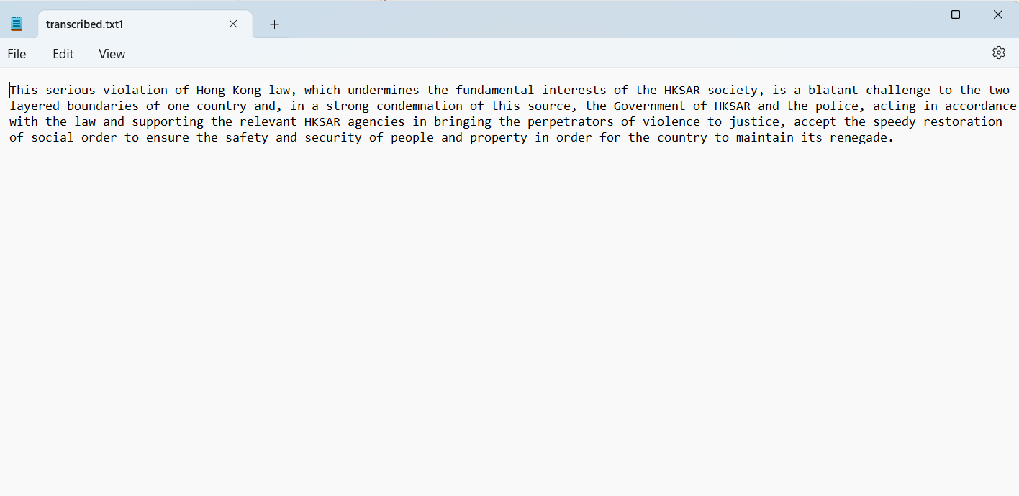

**Fig 3. An Example Translation and Transcription of a Chinese Audio**

**Module 4: Facial Recognition**

#### Expected Costs: $250,000

Facial Recognition will involve training a model using a set of images as a training dataset. This trained model will then be used to match input images with faces from the training set. When a match is found, an image with annotated faces will be generated. The module relies on a GPU for efficient processing, and output methods can be customized as needed.

**Module 5: Document Linkage and Knowledge Graphs**

#### Expected Costs: $150,000

This module provides a linkage between several documents present in a Systematic Database. The file types include and are not limited to Documents, Text files, Images, Videos, PDFs and Audios. The module will provide common elements between several files in form of Graphical Representation and will also preserve Semantic Analysis, Knowledge Analysis, Intelligence Analysis and Syntactical Analysis in the final output. A knowledge base shall be created from scratch with help of experts to finetune the module for the task. The module is expected to complete within 10 months from the start date.

**Project Costs**

#### Total Expected Costs: $950,000

**Technical Details**

- Framework: Django

- User Access: Configurable for both user-accessible and non-user-accessible environments

**Project Milestones**

1. Module Design and Planning

2. Development and Testing

3. Integration of Modules

4. User Interface Development (if applicable)

5. User Access and Authentication Implementation (if applicable)

6. Final Testing and Quality Assurance

7. Deployment

8. Maintenance and Updates

**Conclusion**

The collaboration between DataCompany and ClientCompany aims to create a powerful suite of modules that leverage cutting-edge technologies to address various language-related challenges, enhance document processing, and improve facial recognition and document search capabilities. The project will be developed using the Django framework and can be tailored for different usage scenarios. The successful completion of this project will provide advanced solutions to language translation, document processing, and content retrieval, benefiting both organizations and their stakeholders.